10.3.1 Editors - Geometry Nodes Editor - Sidebar - Node tab
Node tab - Interface panel 1
Inputs / Outputs 1
List 1
Drag handler 1
Search 1
Add Node Tree Interface Socket 1
Sort 1
Name 2
Hide Value 2

Node tab - Interface panel

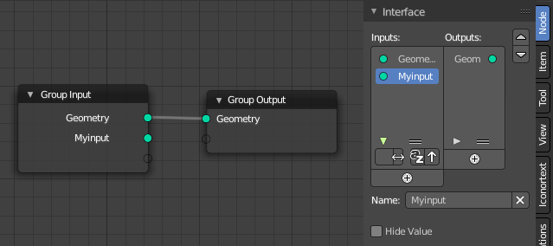
Manage the input and output properties of the Group Input and Group Output nodes.

More than one input slot can be useful when you want to modify the geometry in more than one way.

Inputs / Outputs

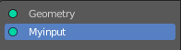
List
List of available input or output slots.

Drag handler
Resize the list.

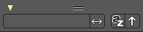
Search
Opens a search field with its options.

Add Node Tree Interface Socket
Adds a new input or output slot to the list.

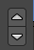
Sort
Move the selected node up or down in the list.

Name
Change the name of the current selected input slot. Type in a new name and hit enter.
The X button at the end will remove the selected input slot from the list.

Hide Value

Hide the input value even when the socket is not connected.

